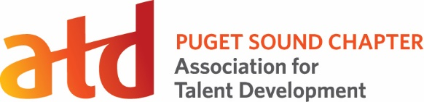
Coordinator Role

Position Title: Allied Partnerships Coordinator

Description:
Term: 15 months

Reports To: Director of Conference & Partnerships

Voting Position: No

Supervisory Duties: No

Committee Members: No

Executive Committee: No

Board Appointed: No

The Allied Partnerships Coordinator increases visibility of the chapter by building strong relationships with local talent development organizations.

Time Commitment:
5-10 hours on average per month, increasing to an average of 10-15 hours during months that partnership events are scheduled.

Key Competencies:
Relationship Building, Event Planning, Communication, Collaboration, Project management

Primary Responsibilities:
- Cultivate relationships with local professional associations that support the broad range of Talent Development competencies within ATD.
- Plan & deliver quarterly virtual events a year for Allied Partners.
- Participate in after action review to ensure continuous development.
- Partners with Evaluation Coordinator to ensure that survey data is captured for each event.
- Learn best practices from established partners; identify opportunities for programming and sharing learnings with ATDps Board
- Work collaboratively with other Board members to ensure volunteer resources are in place at least two months in advance for virtual events.
- Promote partnerships and related events/ activities through ATDps newsletter, social media, the website by working with Director of Marketing & Communication.

Success Measures:
- Builds on established allied partnerships with ICF Washington & Lake Washington HRA.
- Established relationship with new allied partners as appropriate.
- Deliver quarterly events using Allied best practices document.
- Refines best practices document with lessons learned from each event.
- Attends at least one ATD Board meeting to share best practices learned.
- ATDps co-delivers quarterly virtual events. Events evolve based on survey data.
- Co-sponsored events are promoted on website at least six weeks in advance.
- All events/partnerships are published/promoted in newsletter and chapter’s social media.
- Works collaboratively and respectfully with Board members and other volunteers

Privileges: | Additional Expectations:
Free attendance at Partnership events | Member of ATD Puget Sound chapter for term
Position listed on resume and LinkedIn | Post comments/ engage in chapter’s social media
Potential for career pathing to other Board roles | Meet success measures listed above

